# Lab: Introduction to DOM and Events

Problems for exercises and homework for the ["JavaScript For Front-End Course@SoftUni"](https://softuni.bg/trainings/2032/javascript-for-front-end-july-2018#lesson-8965). Submit your solutions in the SoftUni judge system at <https://judge.softuni.bg/Contests/1096/>.

## List of Items

Write a JS function that **read** the text inside an input field and **appends** the specified text to a list inside an HTML page.

### Input/Output

There will be no input/output, your program should instead **modify** the DOM of the given HTML document.

### Examples

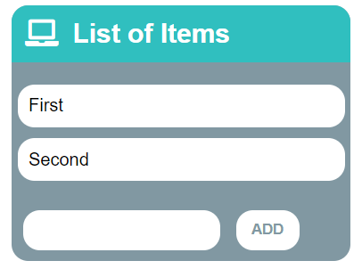🡪 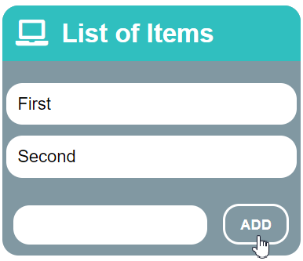🡪 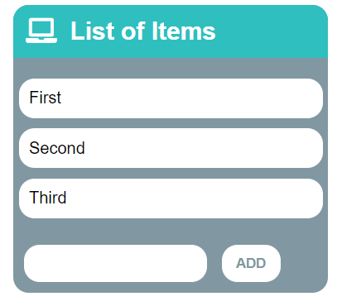

## Add and Delete

Extend the previous problem to display a **[Delete] link** after each list item. **Clicking** it, should **delete** the item with no confirmation.

### Input/Output

There will be no input/output, your program should instead **modify** the DOM of the given HTML document.

### Examples

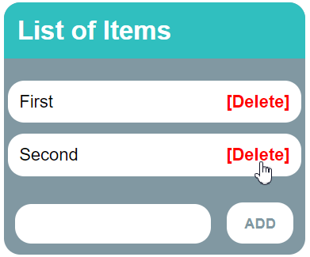🡪 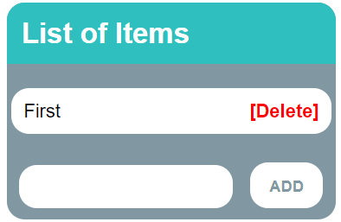

## Delete from Table

Write a JS program that **takes** an e-mail from an **input field** and **deletes** matching rows from a table. If no entry is found, an **error** should be displayed in a <div> with ID "**results**". The error should read "**Not found**."

### Input/Output

There will be no input/output, your program should instead **modify** the DOM of the given HTML document.

### Examples

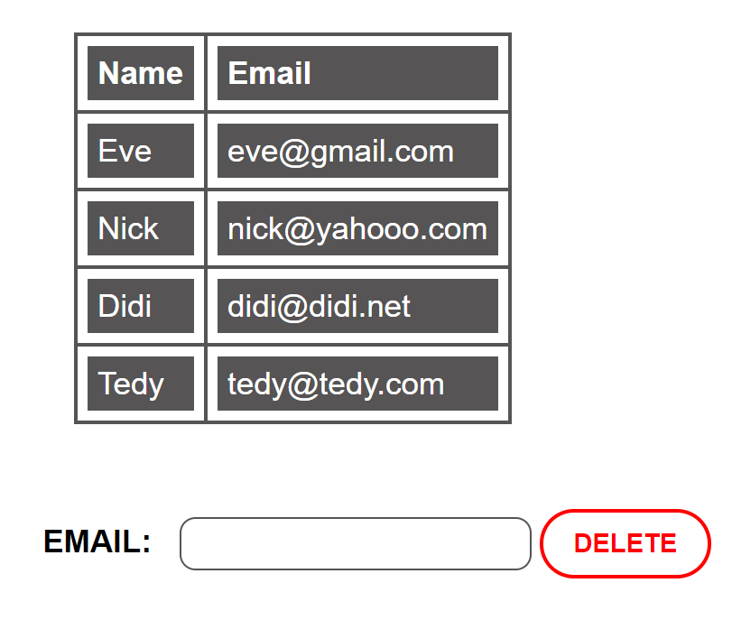 🡪 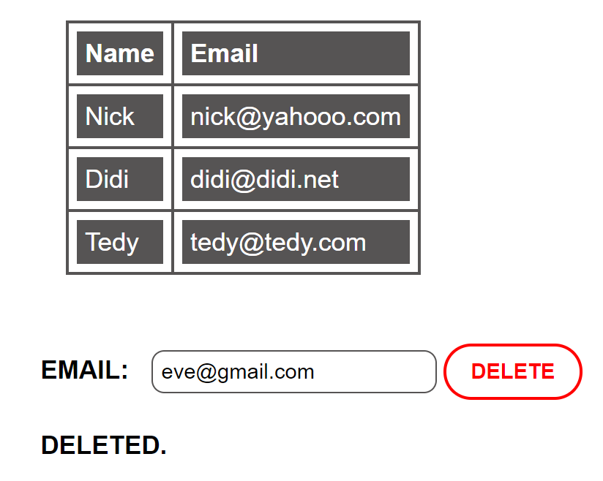

## Stopwatch

Write a JS program that **implements** a web timer that supports **minutes** and **seconds**. The user should be able to control it with **buttons**. Clicking **[Start]** **resets** the timer back to zero. Only one of the buttons should be enabled at a time (you cannot stop the timer if it’s not running).

### Input/Output

There will be no input/output, your program should instead **modify** the DOM of the given HTML document.

### Examples

